Streams Assignments.

Setup:

Create the Following classes:

Class Fruit {String name; int calories; int price; String color;}

Class News {int newsId; String postedByUser; String commentByUser; String comment;}

Class Trader{String name; String city;}

Class Transaction{ Trader trader; int year; int value;}

1: Display the fruit names of low calories fruits i.e. calories < 100 sorted in descending order of calories.

2.Display color wise list of fruit names.

3.Display only RED color fruits sorted as per their price in ascending order.

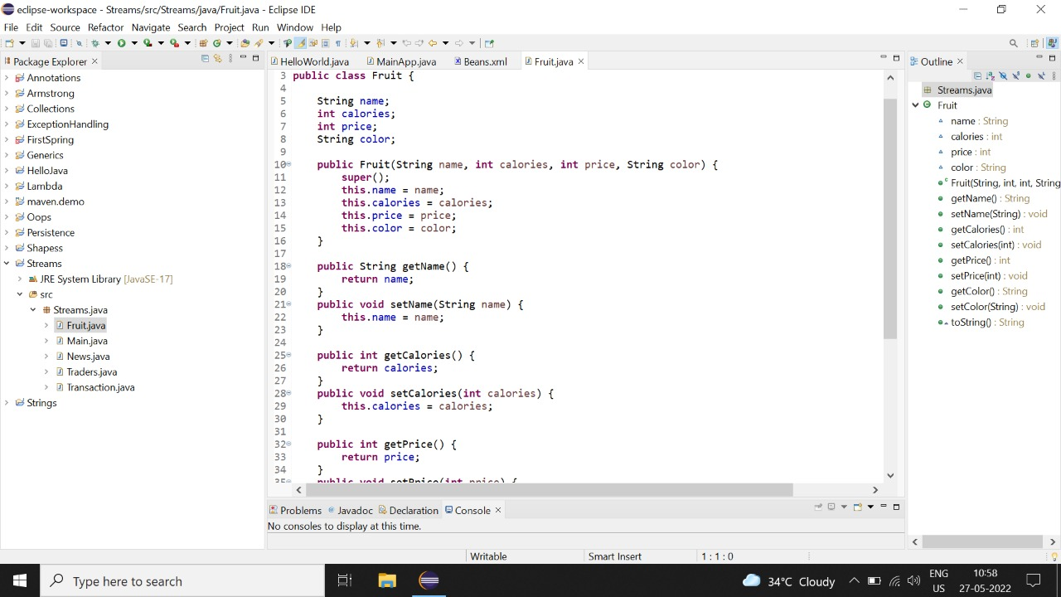

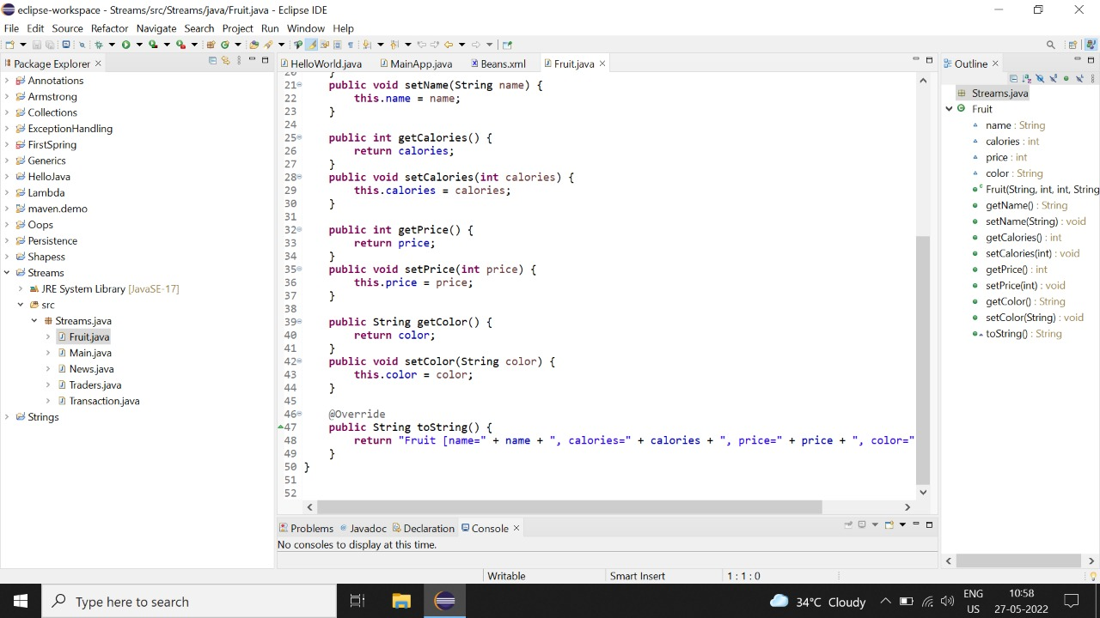

4.Find out the newsId which has received maximum comments.

5.Find out how many times the word ‘budget’ arrived In user comments all news.

6. Find out which user has posted maximum comments.

7. Display commentByUser wise number of comments.

8. Find all transactions in the year 2011 and sort them by value(small to high).

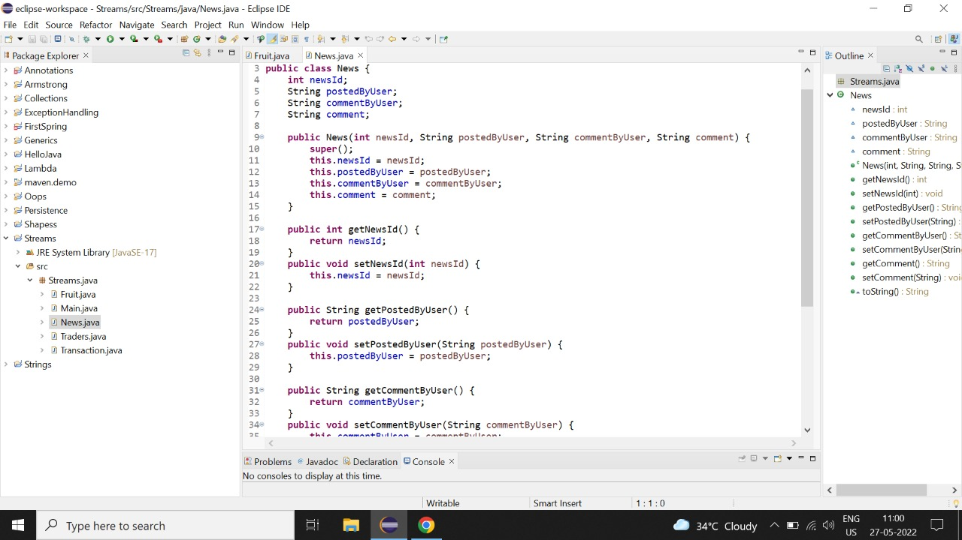

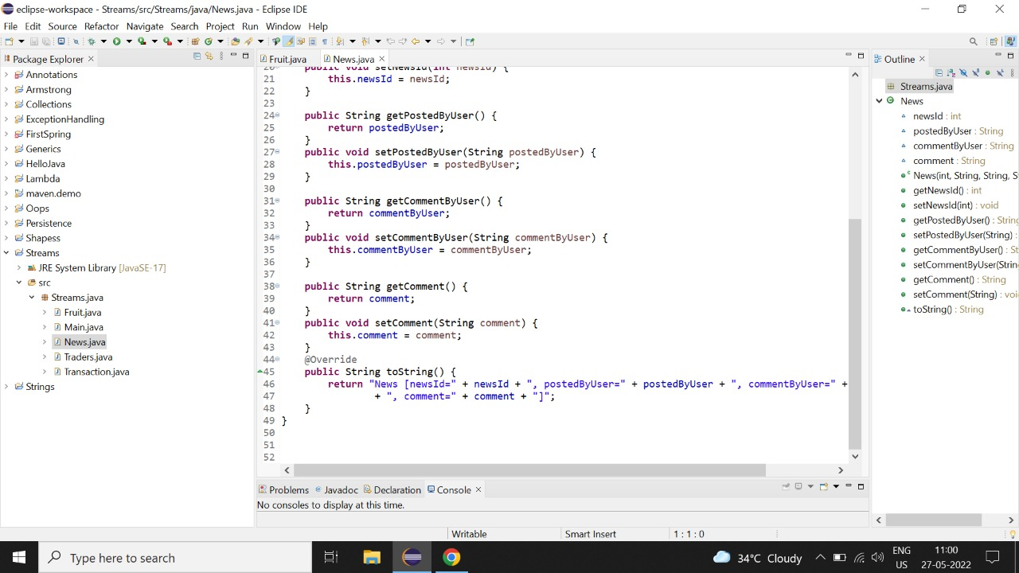

9. What are all the unique cities where the traders work?

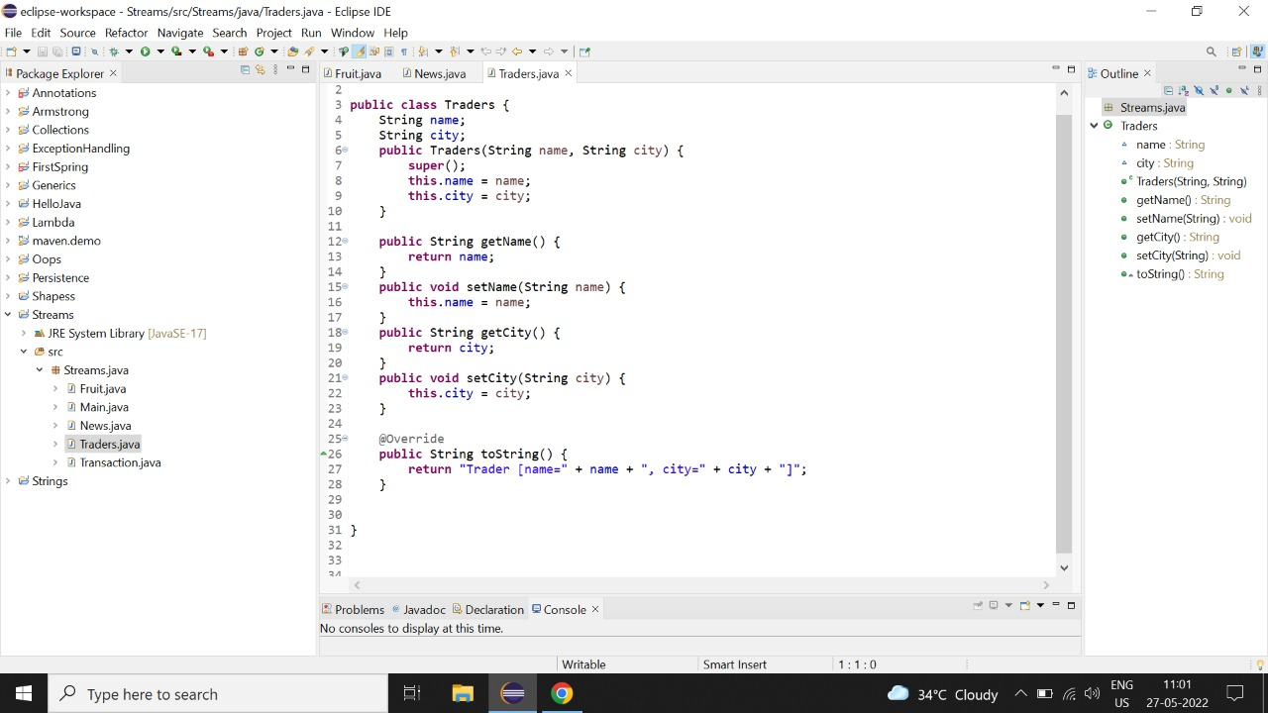

10. find all traders from pune and sort them by name.

11. Return a string of all trader’s names sorted alphabetically.

12. Are any trade based in indore?

13. Print all transaction’s value of all the transactions?

14. Find the transaction with the smallest value.

